**INHA UNIVERSITY TASHKENT**

**DEPARTMENT OF CSE & ICE**

**SPRING SEMESTER 2020**

**SOC 2110 -- INTERNET PROGRAMMING**

**Submitted by**

**Name: AbboskhonRaufov ID: U1810081 Section:003**

**Name: Ilkham Yakubov ID: U1810063 Section:004**

**Name: Firdavs Zikirov ID: U1810041 Section:004**

**Name: Sirojiddinov Mukhiddin ID: U1810051 Section:004**

**LINK TO OUR GITHUB REPO: https://github.com/iuthub/ip-group-project-internet-programming720**

**LINK TO OUR WEB SITE.https://iuthub.github.io/ip-group-project-internet-programming720/**



**Table of Contents**

1 Project Description

1.1Project Abstract

1.2 Competitive Information

1.3 Relationship to Other Applications/Projects

1.4 Assumptions and Dependencies

1.5 Future Enhancements

2 Technical Description

2.1. Project/ Application Information flow

3 Project Requirements

4 Project Design Description

5Output Screenshots

6 References

**PROJECT DESCRIPTION**

**1.1Project Abstract**

This project is Online Dorms Systems which allows users to book their room in the dorm from anywhere; this is an automated system where the user can search the availability of rooms in the dorm. The search can be done based on the dates. The rooms that available are come with the status available, it will display all the rooms available as of that particular search date.

**1.2**. The objective of this application is to develop an online dorm system for Improving Software Quality and Reliability is useful for applications developed in an organization. This system can be used for reduce problems of student against an application/module, assigning dorms to individuals and solving problems of student.

**1.3** Relationship to other applications the existing system in does not contain any online facility to book the dorms remotely. All they have in our University is the applicant, who is willing to book or reserve a bed in the dorms have to go and meet the dorms administrator in personnel and have to fill up application form so that the administrator can review the applicant’s information and then administrator allocates a bed in dorm. This all process goes only on paper based.

**1.4** Assumptions and Dependencies The proposed system organizes the data effectively. The online dorms system for improving application Quality and Reliability is a web-based application that can be accessed throughout the organization. It can be useful application that can be taken as reference for any kind of situation or project.

**2 Technical Description**

There are certain problems with the current dorm management system in the university. Sometimes the application may be lost completely without even knowing to the administrator and the people who are participating in the application due to the negligence of the either the administrator or the people working under the administrator. And there is no security for the user or applicant’s information.

**3. REQUIREMENT SPECIFICATIONS**

Software and Hardware Requirements:

Software Requirements:

Technology:

Php

Web Technologies:

HTML, CSS

Database: MySQL

Hardware Requirements:

Processor: Pentium (Min)

RAM: 1GB

**4. PROJECT INTERNAL/ EXTERNAL INTERFACE IMPACTS AND SPECIFICATIONS Database Design:**

We have used MySQL database to store the data. This database can be run on internet and can also be on our local host, we have used xampp control panel which holds both MySQL database and tomcat server. Initially we have created database with names “records” and “withdrawal dB” for equipment request and withdrawal form respectively. Each data base includes several tables, records database includes two tables named report1, which holds the information about the professor who has requested for equipment and all about that request The following figures shows the Tables in the database.

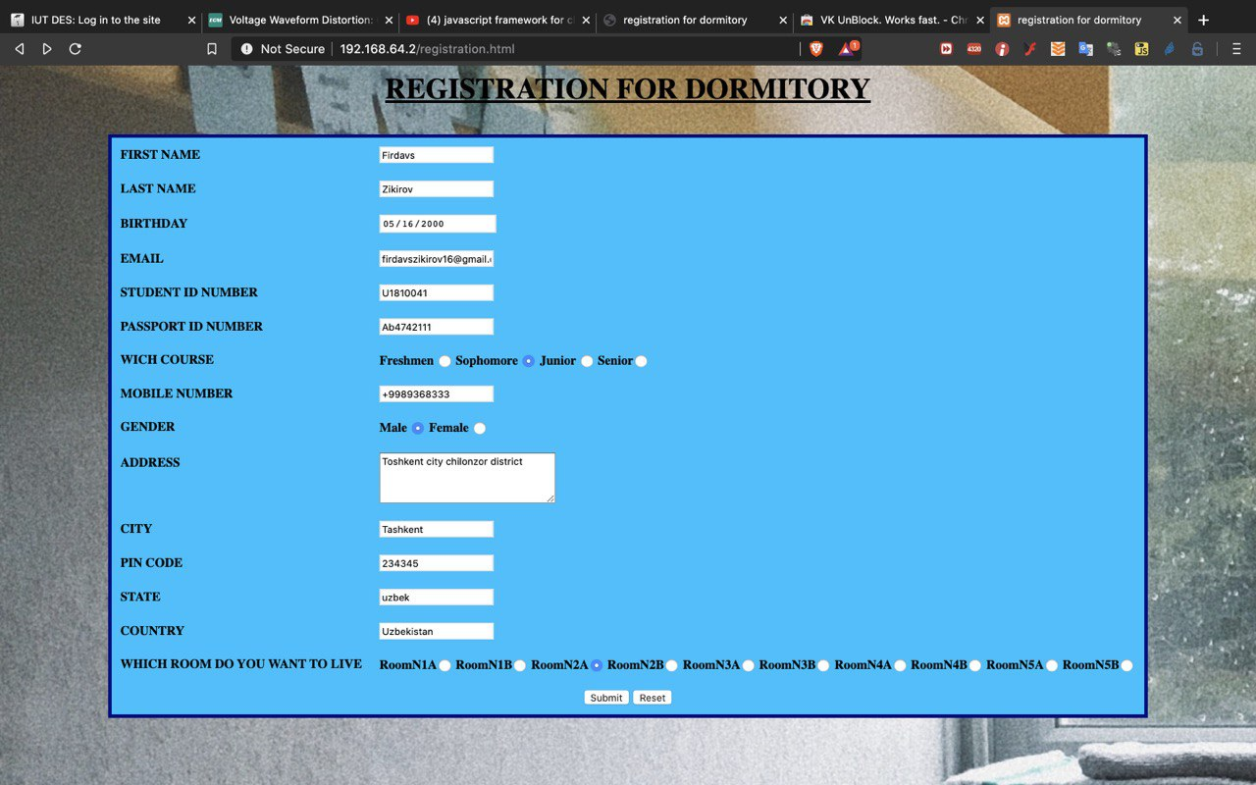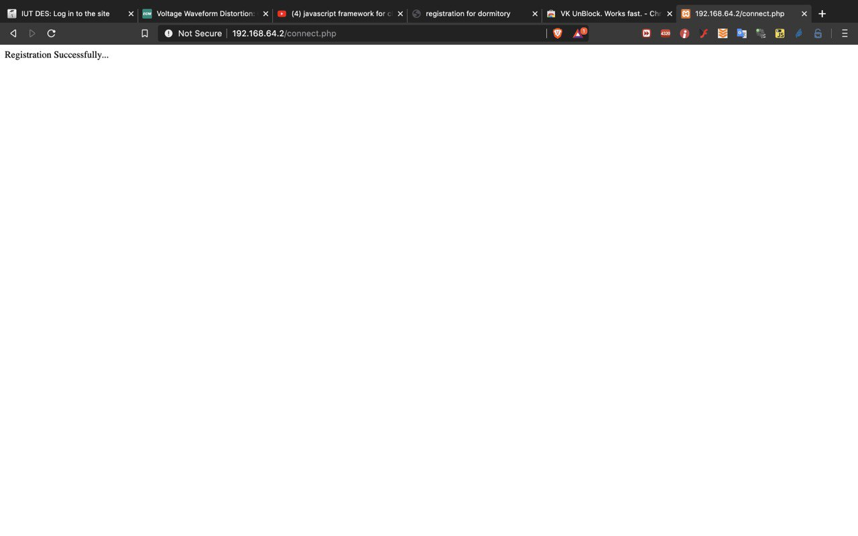 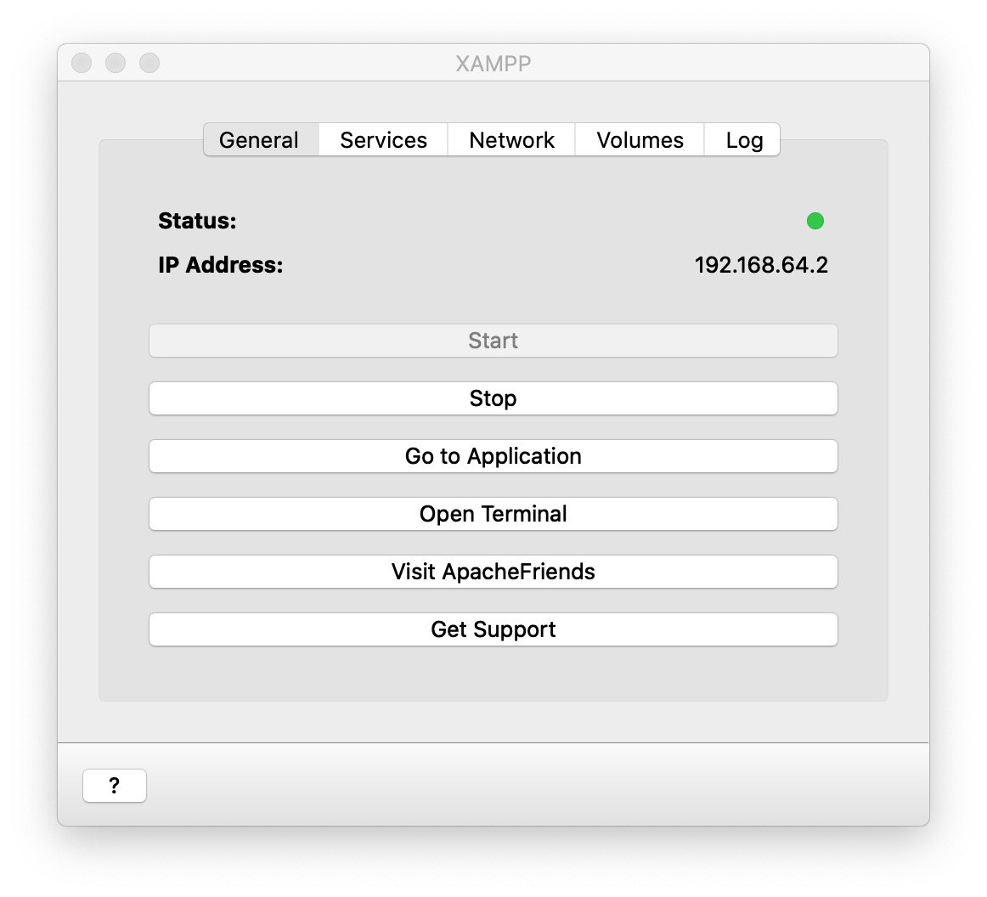 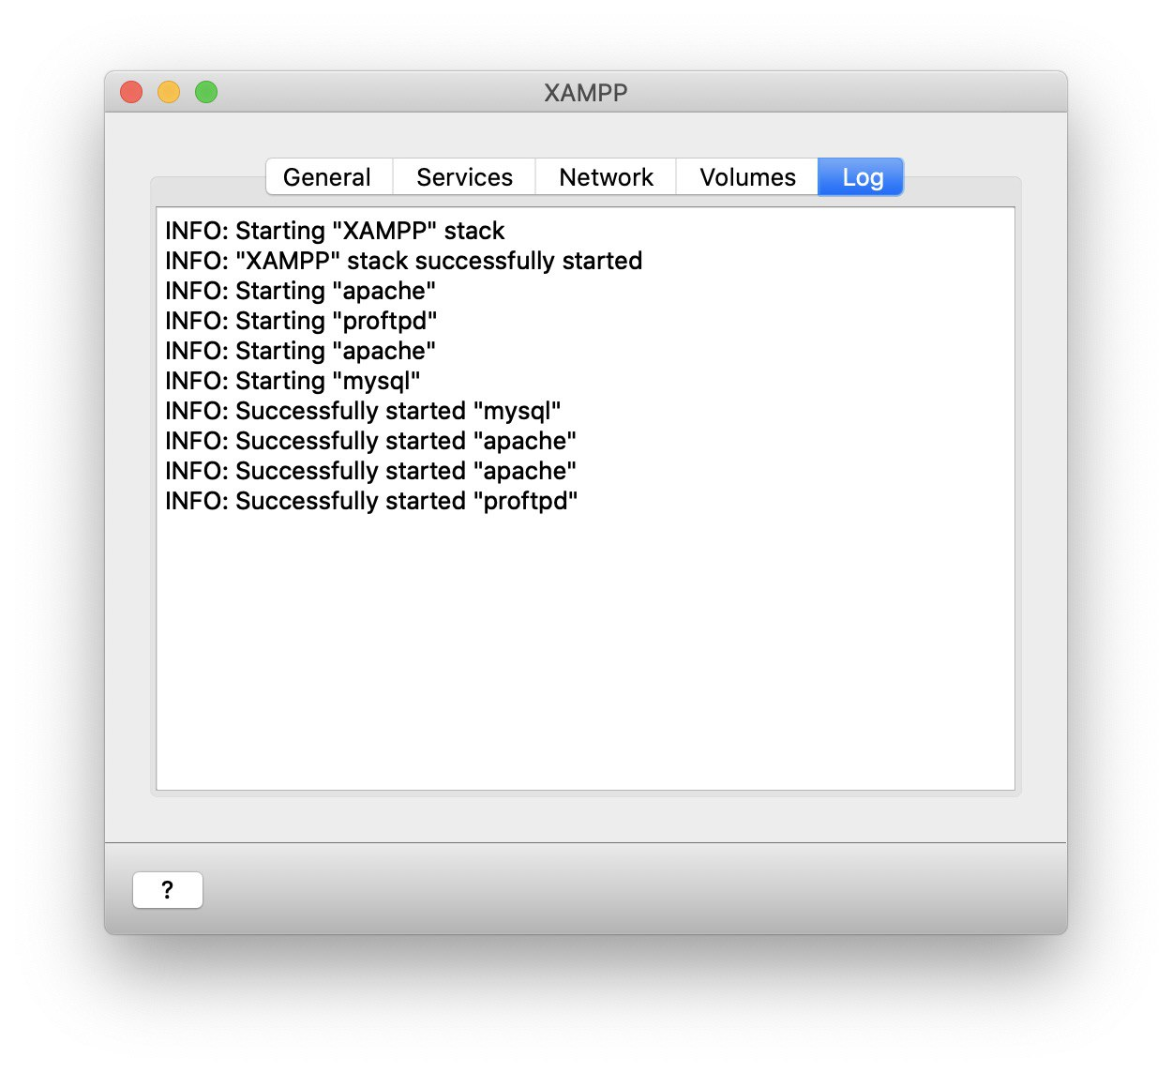 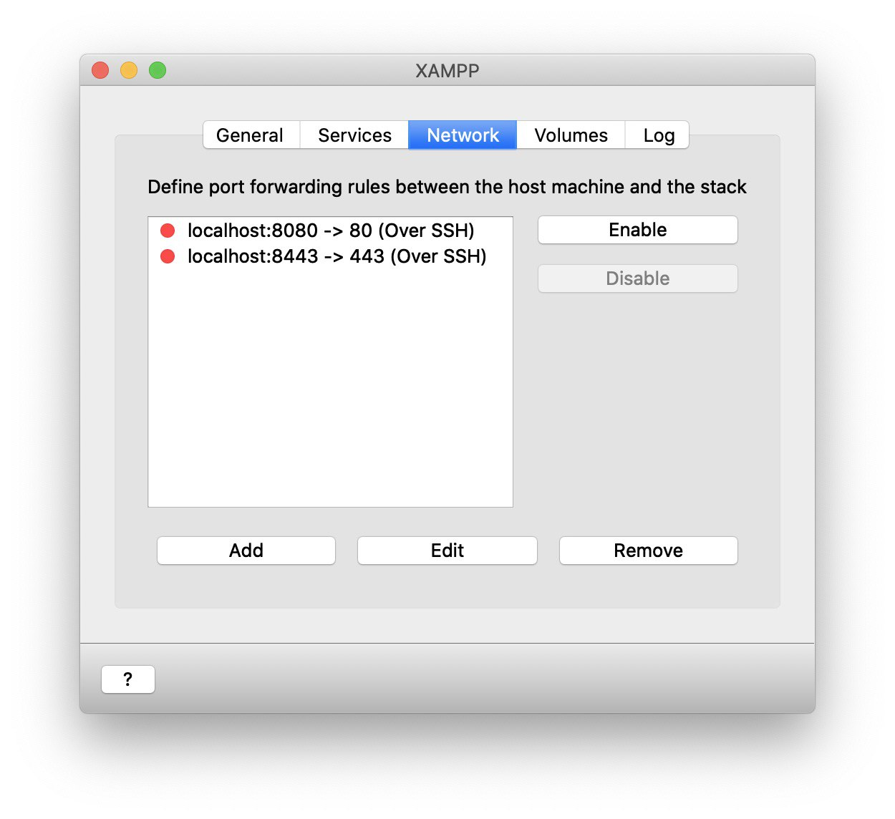 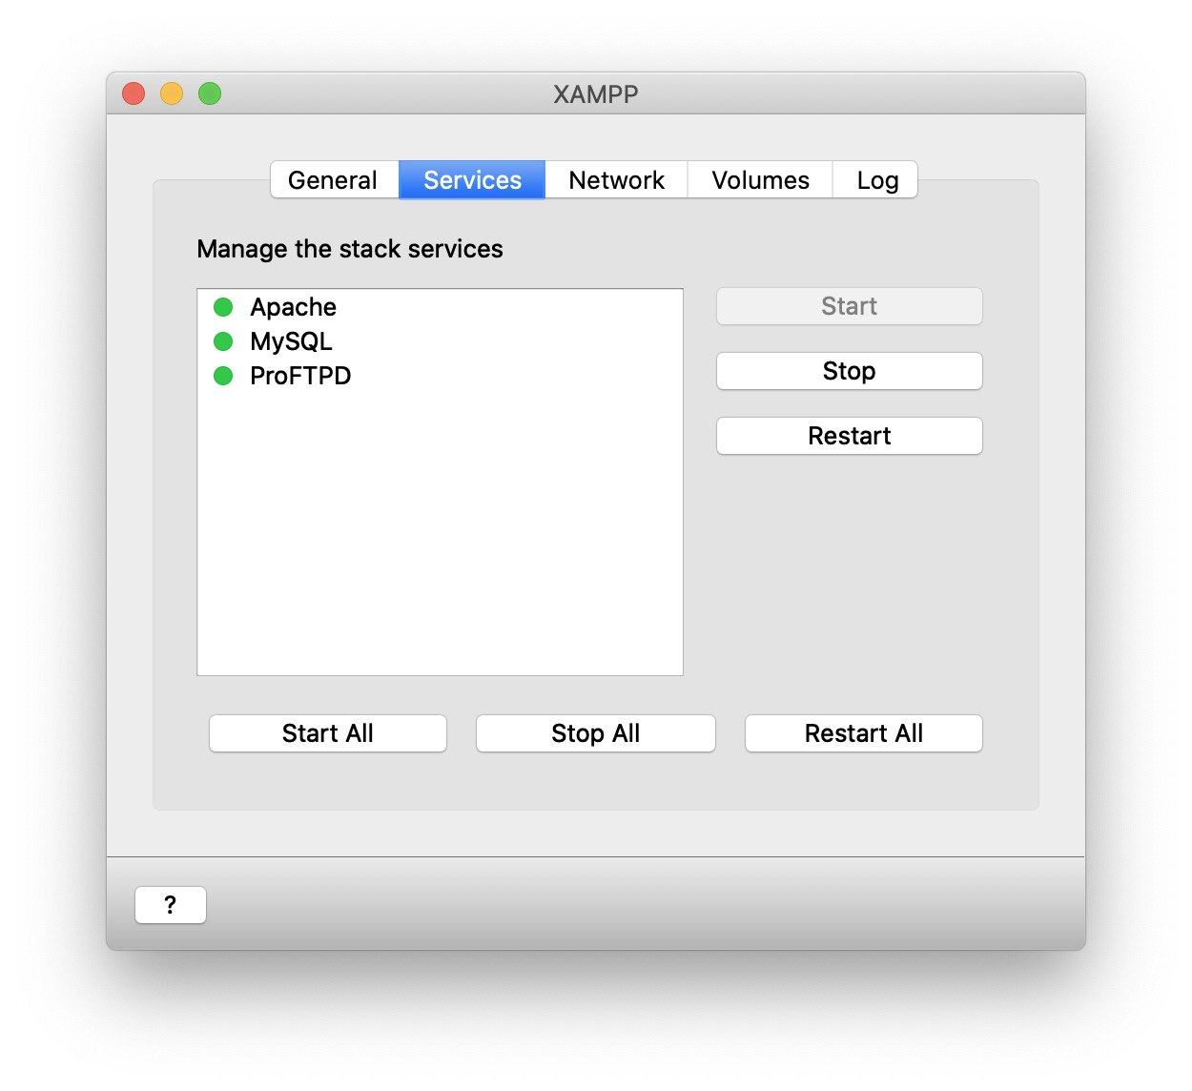 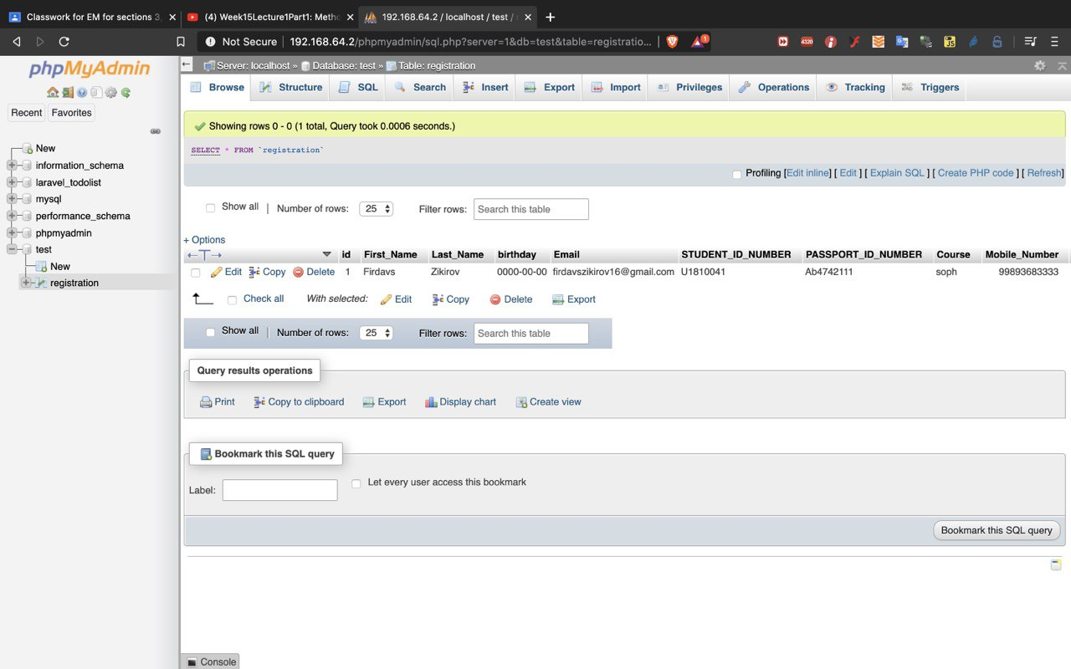 Table 2 – Customer Details

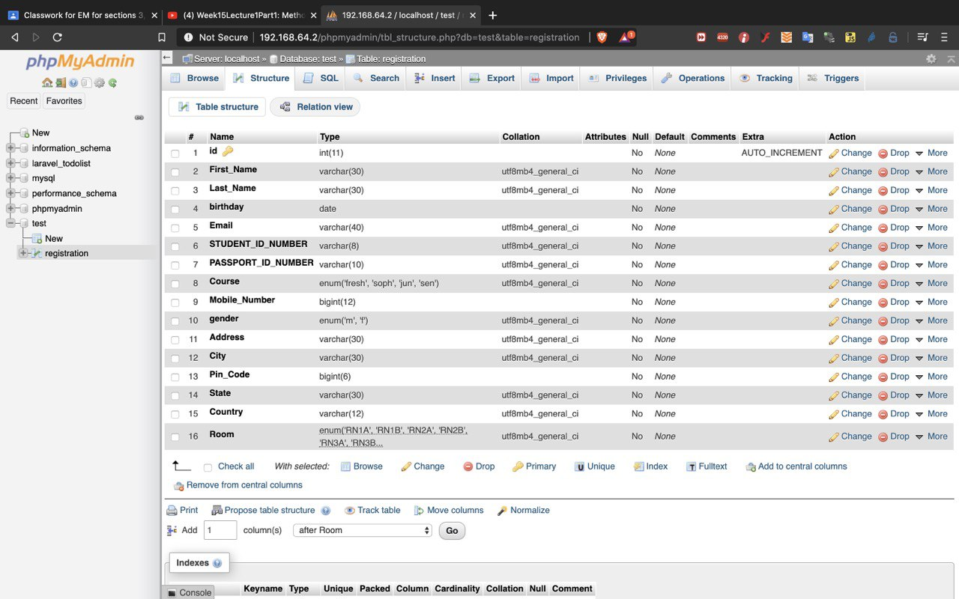

**5 OUTPUT SCREENS:**

Home page:

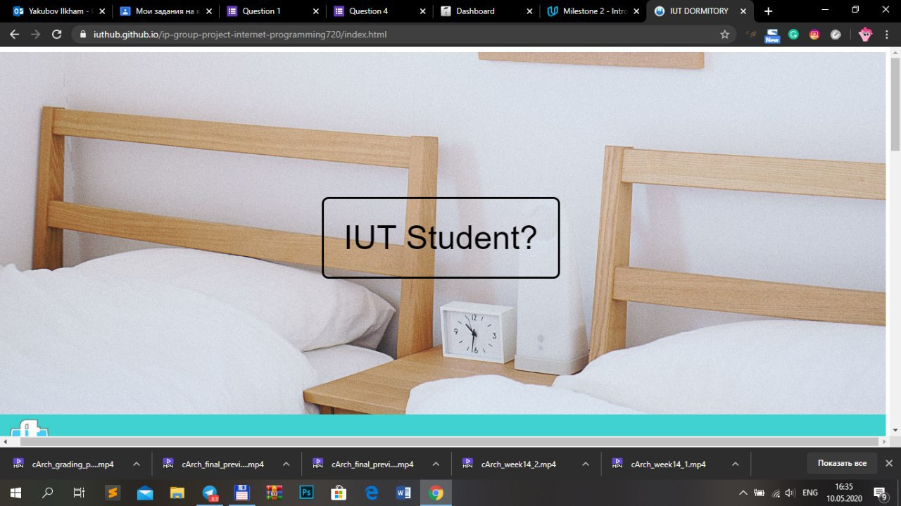

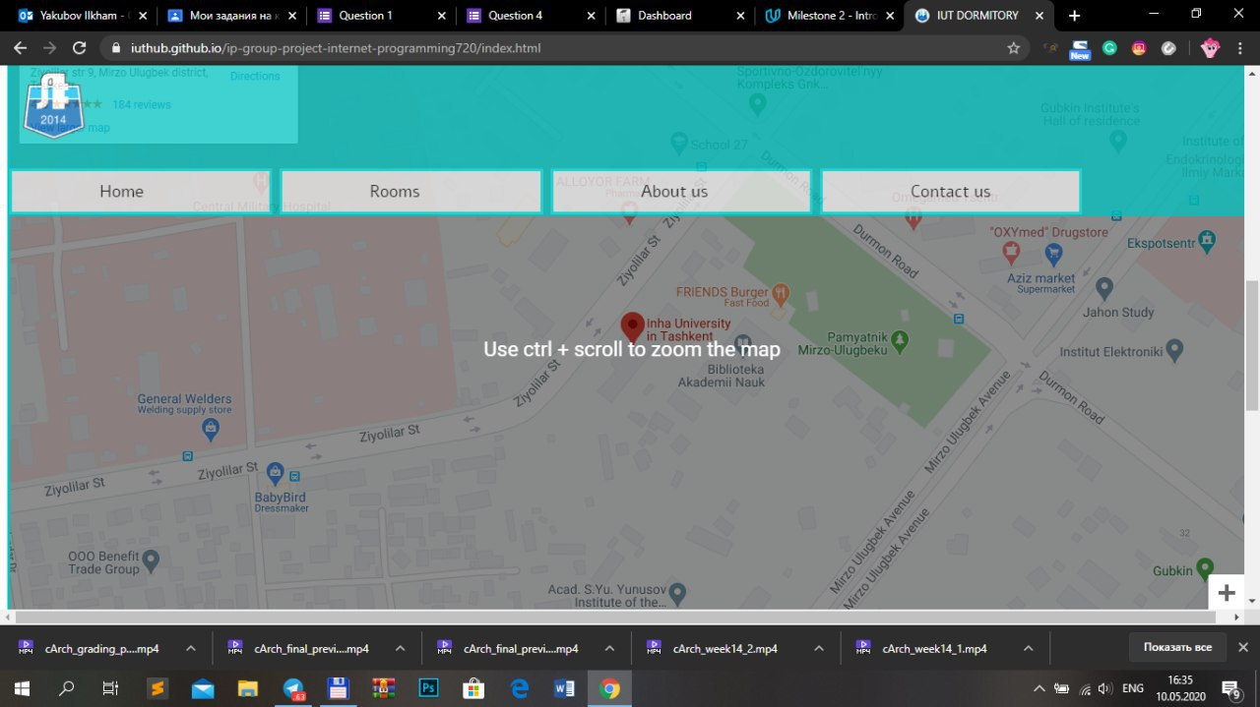 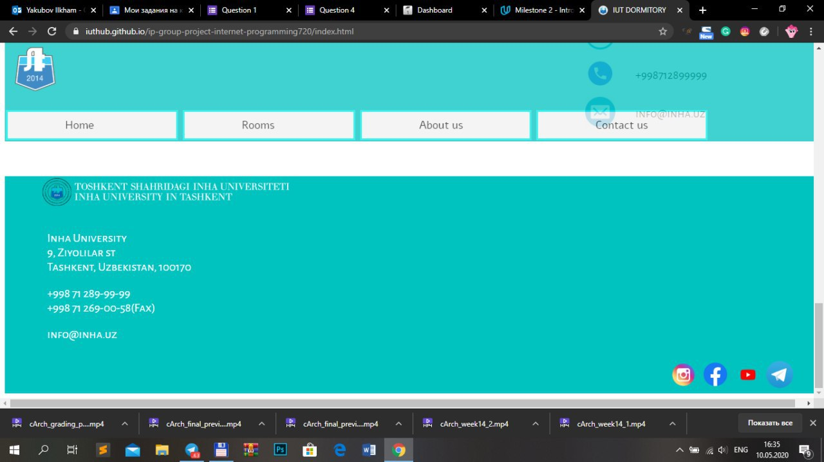 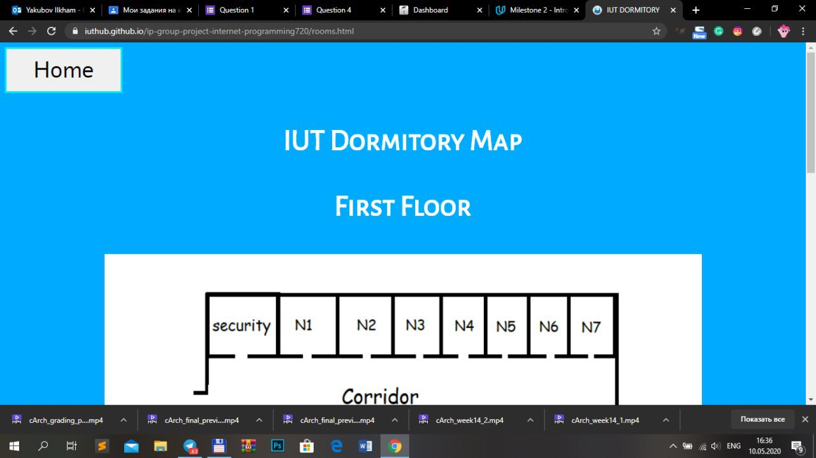 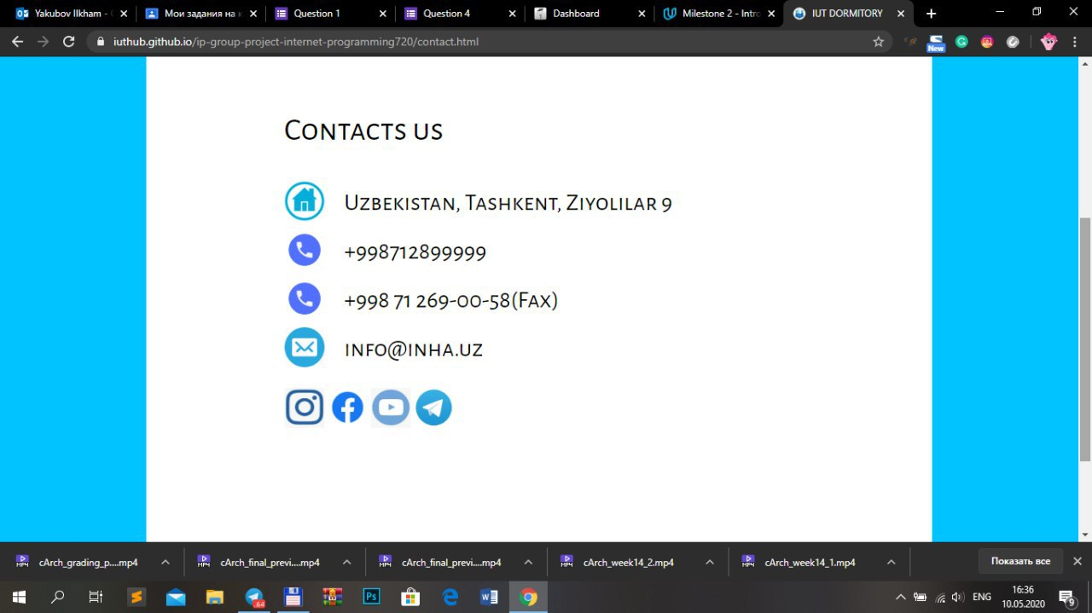

User Login & Registration page

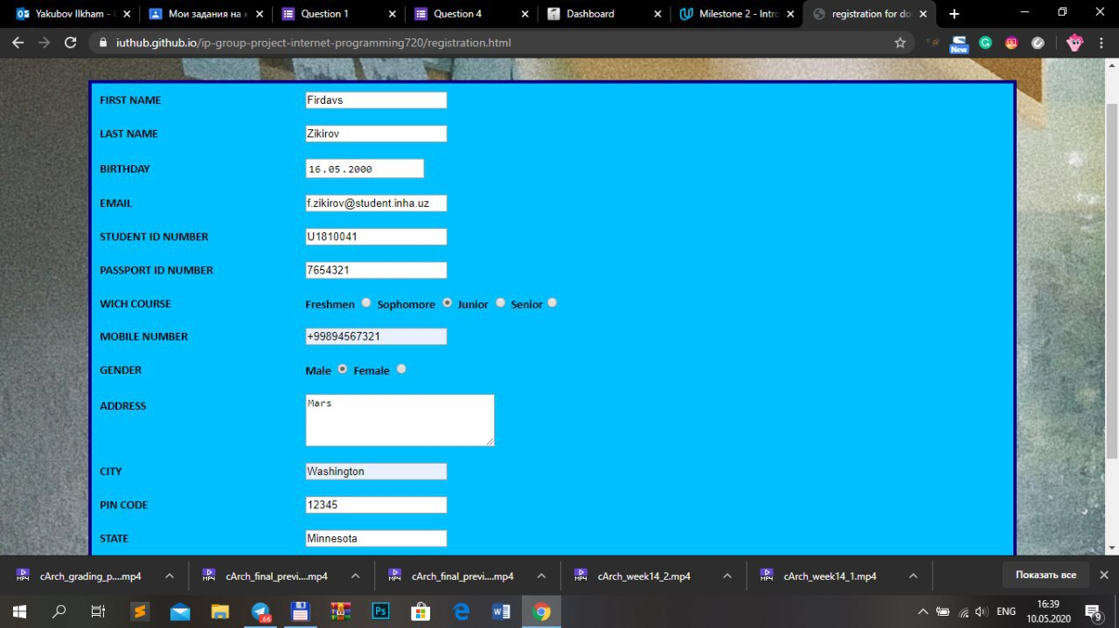

**6 REFERENCES:**

Git and GitHub:

• <https://www.codecademy.com/learn/learn-git>

• https://try.github.io/levels/1/challenges/1

• Branching/Merging: http://learngitbranching.js.org